**EMPATHY MAPPING**

An interview for empathy aims to look at the world from the point of view of a person, team, or organisation.

The tool is typically used at an early stage in the design thinking cycle to understand the context in which a person acts. Only then can the development of a solution begin.

**How might this tool be helpful in your process of creating something innovative in your organisation?**

* It builds up a solid understanding of the user’s needs, emotions, motivations, and ways of thinking.
* Gain insights that would have remained hidden in a superficial consideration (e.g. a person’s frustration and deeper motives).
* Find out in the context of the usage which task flow the person prefers and what mental model he bases it on.
* Validate information already obtained and gain new insights.
* Establish a solid basis for discussions with your innovation development team.

INTRODUCTION - PERSONA

Who are you?

Where do you work?

How long do you work with young people?

What is the nature of your work? Full-time employed? Part-time? Voluntary?

What are other important things I need to know about you?

Now let’s explore specific aspects of your work, and I am interested in how do you (do something linked to the product you are trying to develop) deal within your job?

TASKS

What questions do you need to be answered?

What tasks are you trying to complete in your work?

INFLUENCES

What things/ people or places influence the way you do your task/job?

OVERALL GOAL

What is your ultimate goal?

What are you trying to achieve?

How do you feel about the process of achieving your goal?

PAIN POINTS

What pain points (problems/ challenges) you are experiencing while doing this task/job?

Why are you experiencing it?

FEELINGS

How do you feel about your experience in accomplishing certain tasks/job?

What really matters to you?

You can draw a mind map to add all the main aspects on one page.

Combine all the interview mind maps and sense what the real pressing issues are that require certain improvement in the organisation. This might be a possible direction for innovation.

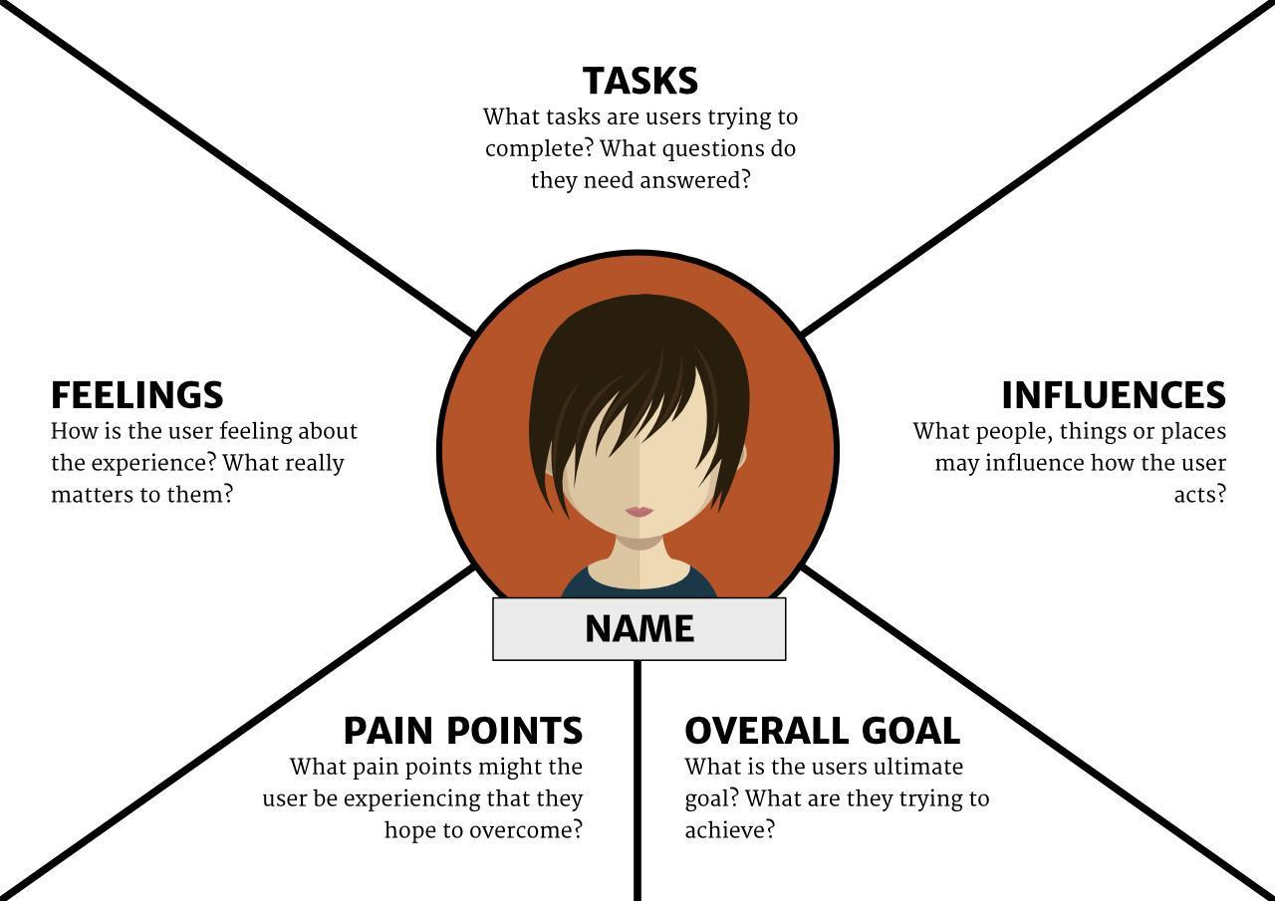

Source: <https://boagworld.com/usability/adapting-empathy-maps-for-ux-design/>